An airline company requires your services to design software for their Boarding Pass Generation System. A sample boarding pass is provided in Figure 1, which would be provided to a passenger who will be boarding a place.

​

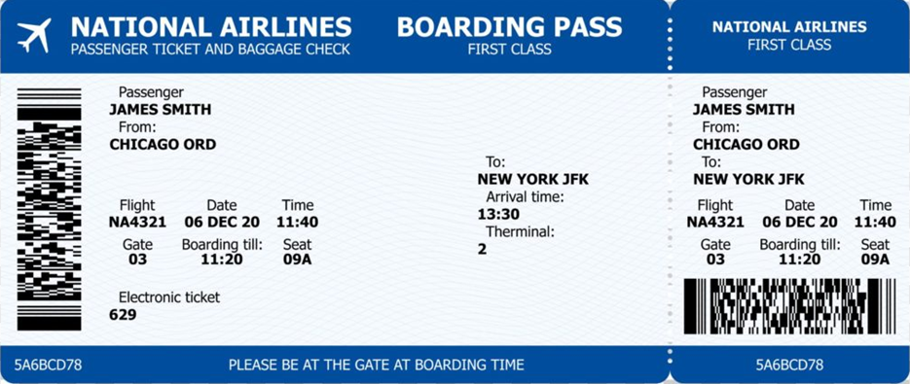

You are required to do the following:

1. Identify the use-cases for the software. Draw the UML use-case diagram and include supporting use-case descriptions. At least 3 scenarios must be identified.

​

1. Identify the objects and their respective classes. Draw the UML class diagrams and include supporting descriptions to explain the relationships. At least 4 classes and respective relationships must be identified.

​

1. For all the identified classes, create Python classes with the constructor, attributes (at least 5), and required setter/getter methods. Identify and include other required function headers in the classes where the function's body is just a *pass* statement and include a comment to indicate what the function should achieve.

​

1. Create objects of all the identified classes and use the object’s functions to populate and display all the boarding pass details shown in the figure.

​

**Submission:**

Submit a report (single PDF file) that has the following sections:

a. UML Use-Case Diagrams and Description.

b. UML Class Diagrams and Description.

c. Python classes (copy-paste the code, NOT an image of the code). The code must be well documented with good coding standards followed.

d. GitHub repository link, with access made public: The GitHub repository will have a record of your work. The repository would indicate the cumulative progress of your work in the assignment over the time you have worked on it.

e. Summary of learnings

**Learning Outcomes Added**

* [LO1_OOAD](https://forum.uae.minervaproject.com/app/outcome-index/learning-outcomes/LO1_OOAD?course_id=1934): Analyze and design software that map real-world entities and relationships using Unified Modelling Language (UML) notations.
* [LO2_OOProgramming](https://forum.uae.minervaproject.com/app/outcome-index/learning-outcomes/LO2_OOProgramming?course_id=1934): Create working object-oriented programs in a computer language that are well- structured, error free, and can solve computational problems.

See the link below to use the code

<https://www.youtube.com/watch?v=R_E3ht-wWeM>

<https://www.youtube.com/watch?v=mn7mYdKln5Q>

<https://www.youtube.com/watch?v=Kj-oK05kZew>

<https://www.youtube.com/watch?v=ZV4CyzvJv50>

<https://course-resources-uae.minervaproject.com/uploaded_files/production/00285096-0912/video-tracing-code-nov-23-2022.mp4>